Retail Data Warehouse Project Log

Objectives
- Design and build a retail analytics warehouse
- Implement dimensional modelling (Star Schema) for OLAP
- Move data from flat file into new data structures
- Conduct testing on data warehouse for data integrity
- Test and improve query performance using indexing
- Create cubes for analytical reporting and future dashboard integration
- Clean data and conduct data exploration using Jupyter & Python
- Create dashboard for stakeholder presentation
Technologies used
- DBDiagram.io – Design of OLAP ERD
- SQL – Database management and querying
Data
The data used for this project is synthetic and contained within a csv document labelled retail_sales_flat.csv. The data replicates primary data generated from a retail store detailing transactions made by its customers. There are 29 columns within the dataset which include order, product, customer and store details. The measurement features within the document include pricing, sales, discount, shipping and quantity.

1.OLTP Design and Creation
To start the project, the data needed to be transitioned from the csv file to a functional OLTP database, the reasoning behind this decision was data integrity, reliability and improved functionality. In this instance, a MySQL database was created with a staging table which was designed to hold the transactional data. As the key objective of this project was surrounding the OLAP, the design of the OLTP was kept as simple as possible however this can be updated with future development if necessary.
The staging table directly mirrored the csv file columns and data formats, the only changes made was that the order_id and order_item_id were both used to define the primary key for the table, previously the only primary key was the order_id column.
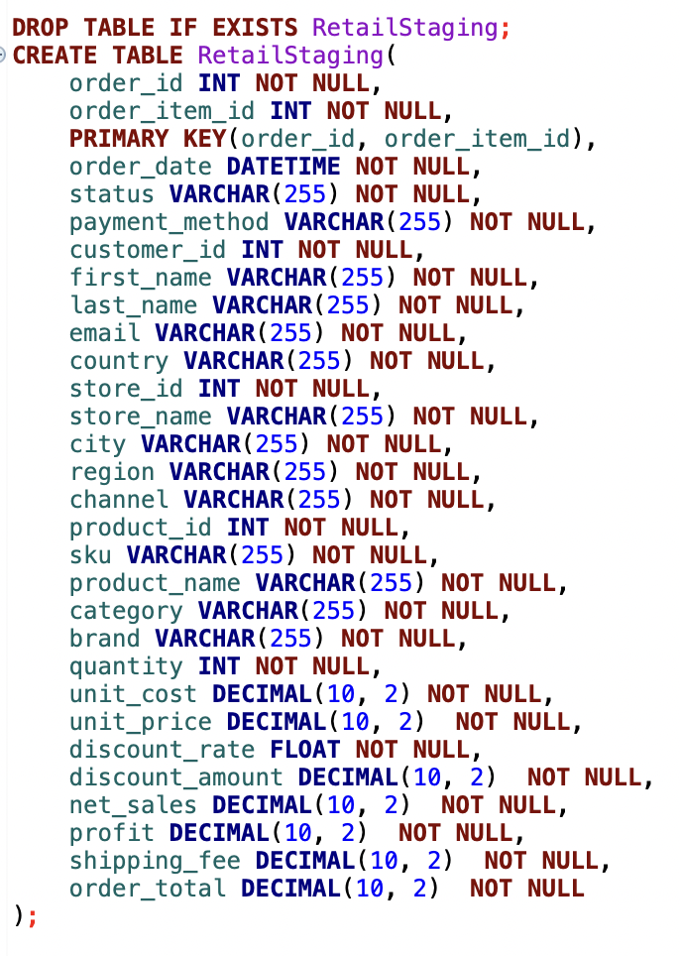
With the code above, you can see the SQL code used to create the OLTP. A few things to note here are;
255 characters were used for each VARCHAR data type, although this could slightly effect performance of the database, this decision was made to ensure flexibility of the input data.
Decimal was used as a data type as opposed to float, as it was a form of currency, this would help with performance. Float was only used for discount rate which was measured as a percentage out of 100.
A Duel primary key has been set as this logically describes the data – Each row displays a product purchased within an order.
2. OLAP Design
After creating the staging table within the database, I started on the design on the OLAP. To create a visual design of the OLAP I used DBDiagram, the result of this can see seen in ‘/ERD/ Retail ERD.png’.
The first consideration to be made was deciding on what would be considered as the measures and what would be considered as dimensions for the final facts table. While splitting the features, it was decided that the facts table would contain two degenerate keys (order_id & and order_item_id )as the combined primary key, this decision was made as it seemed logical to preserve this information for traceability and to ensure the uniqueness of each entry rather than create an additional order dimension. In essence each row in the facts tables describes a product purchased within an order.
The alternative to this would have been an order dimension which would include ‘channel’ and shipping information however since the ‘shipping_fee‘ column can also be used as a measure it would be more effective to not create an order dimension table. The final split can be seen below.
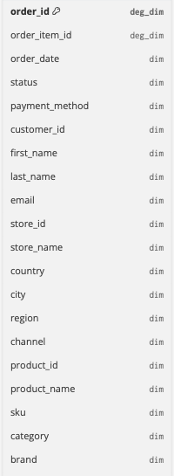 | 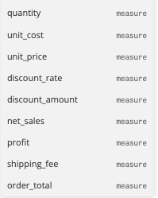
Following the allocation of measurements and dimensions, I had decided on 7 dimension tables and 1 FACT table as the final schema of the OLAP. The dimension tables were:
- dim_date
- dim_time
- dim_customer
- dim_store
- dim_status
- dim_payment
- dim_product
To review which columns were moved into each dimension, please refer to the ERD diagram within the project

